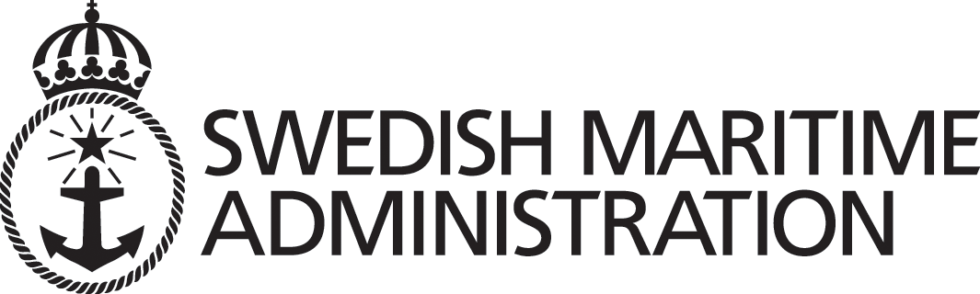
ADMIRAL MAKAROV
STATE MARITIME ACADEMY

Tentative schedule PSC/ISM training
at Makarov Training Centre
5 – 6 December 2006

 | Tuesday 5 December
10:00 | Port State Control, general elements and legislation | H Ågård
11:00 | Coffee break
11:30 | The ISM code and Port State Control part 1 | H Ågård
12:30 | Lunch
13:30 | The ISM code and Port State Control part 2 | H Ågård
14:45 | Coffee break
15:15 | Group work and preparation for visit onboard ship
16:30 | End of day 1
Wednesday 6 December
10:00 | M/T «_____» (will be settled later), Visit onboard, guided tour and hands on training on checking of all certificates and other PSC related issues.
13:00 | Lunch
15:00 | Discussion and conclusion | H Ågård
16:00 | Closing ceremony and delivery of course certificates | All

