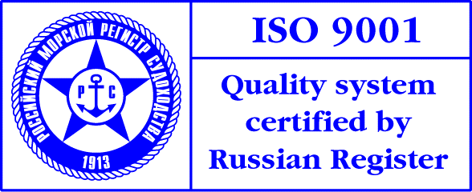
PRESS-RELEASE

Russian Forum on Simulator Training and Certification of Maritime Specialists
was held October 02-04, 2006 in St. Petersburg

Admiral Makarov State Maritime Academy together with FSUE MorSvyazSputnik held Russian Forum on Simulator Training and Certification of Maritime Specialists for safety of navigation on October 02-04, 2006 in St. Petersburg.
The Forum focused on the following issues: recent international and Russian legislation concerning simulator training of maritime specialists, certification and operation of training centers; new IMO and ILO documents; training of crews and coastal specialists according to the latest STCW Code and SOLAS amendments; innovative shipborne equipment for safety of navigation; simulator training of oil and LPG\LNG tankers personnel; methods of simulator training of deep-sea vessels’ personnel; upgrading of specialists engaged in maintenance of coastal equipment for safety of navigation (GMDSS, AIS, VTMS); common standards of simulator training, competency assessment; methods of competency assessment at training centres and sea ports’ administrations; training and certification of sea and river pilots; innovative technical means of training and competency assessment; quality and adequacy of simulator models; use of simulators for investigation of sea accidents, development of projects on port and transshipment terminals’ construction; human factor, methods of operator error reduction, aspects of tiredness; psychological aspects of combating emergency on board a ship; stress overcoming by crew members, pilots and VTMS operators.
The Forum was participated by the representatives of Ministry of Transport of Russian Federation, Federal Agency of Sea and River Transport, Federal Transport Supervision Service, FSUE MorSvyazSputnik, FSI Maritime Security Service, FSUE Rosmorport, pilot organizations, native and foreign leading producers of radio, navigational and simulator complexes and specialists from shipping companies, classification societies, sea port administrations, scientific, designing organizations, educational institutions and training centres.

