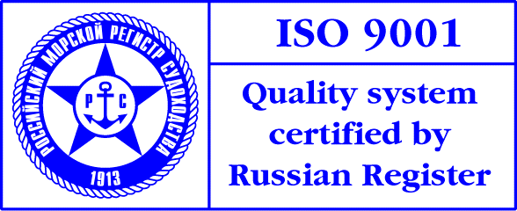
PRESS-RELEASE

International seminar on Security of Sea and River Transport

ISSUES of SECURITY of SEA AND RIVER TRANSPORT: REsults, EXPERIENCE, PROBLEMS AND future trends

The Seminar was held in St Petersburg, October 31 - November 1, 2006, by FSI Maritime Security Service and Admiral Makarov State Maritime Academy under the aegis of Ministry of Transport of the Russian Federation.

Since International Code for Security of Ships and Port Facilities came into force on July 1, 2004, more than 2 years have already passed. As the phase of implementation of ISPS Code is completed, certain experience has been accumulated alongside with issues requiring participation of all the parties implementing ISPS requirements in discussion.
The Code was adopted by the International Maritime Organization (agency of the UN) to prevent terrorist acts on the sea transport and combat growing distribution of drugs as well as illegal emigration.
By now Russian shipping companies and port facilities have obtained the first experience of cooperation both within Russia and abroad in the framework of the new requirements for maritime security.
The aim of the International Seminar on Security of Sea and River Transport was to provide an exchange of experience and an awareness of present and future trends of maritime security measures implementation for all the member of transport activity.

The seminar focused on key issues:
- Results, experience and problems of implementation of ISPS Code in the Russian Federation.
- Operating standards of security. Certification of security systems for sea and river transport units.
- Russian vessels meeting security requirements. Inspectorates’ reports from foreign ports.
- Inspection procedures in accordance with Chapter XI-2 of SOLAS-74 and ISPS Code. Key features. Preliminary results.
- Problems of safe transportation of dangerous cargo.
- Ratification of ILO 185 Convention in Russia concerning seafarers’ identification and subsequent legislation changes. Implementation problems.
- Port facilities’ preparation for examination for certificate of compliance.
- Interdepartmental cooperation for ISPS implementation.
- Supplementary technical security aids for port facilities.
- Reports on compliance of port facilities for international and national administrative documents concerning security.
- Counter terror security of navigable hydraulic structures and other unconventional objects.
- Key issues of specialists’ training.

The seminar was attended by the representatives of the Russian Ministry of Transport, Federal Agency of Sea and River Transport, Federal Transport Supervision Service; port captains of Russian Federation, Russian Port Control inspectors, shipowners, broker companies, crewing companies; classification societies; sea and river mouth ports; transport and power engineering security expert organizations; research institutes; educational institutes and ISPS training centres.

The Seminar was participated by Head of Federal Agency of Sea and River Transport A.A. Davidenko, Director of the Department of the State Policy for Sea and River Transport of Mintrans A.U. Kalyavin, Head of FSI “Maritime Security Service” N.V. Savelyev and President of the Union of Russian Shipowners M.A. Romanovsky.

Showcasing of shipborne and port security equipment, information systems, reference materials was held during the Seminar.

