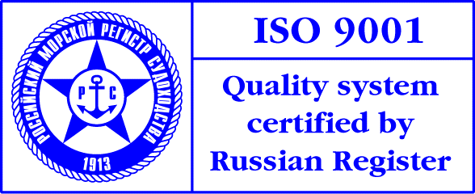
PRESS-RELEASE

Admiral Makarov State Maritime Academy and Russian Sea and River Bunker Industry Association signed an agreement

Admiral Makarov State Maritime Academy and Russian Sea and River Bunker Industry Association signed an agreement of cooperation.
Russian Sea and River Bunker Industry Association was established in July 2005 in St. Petersburg. Currently it comprises 25 companies, operating in all important shipping regions of Russia.
The agreement provides joint educational programs, specially designed for bunkering companies’ personnel.
Vitaly Kovalev, President of Association, commented: “ Bunkering, or in other words fueling of a ship, is a sophisticated port service that includes storage, transportation and transferring of oil products. None of Russian institutes trains specialists for this business, personnel is learning directly at work. That’s why the Association is placing an emphasis on training programs. We completed the training of Dangerous Cargo Transportation Consultants in June and upgrading of legal experts in November.”
The training program will be intended for oil spill response and combating its consequences. Sergey Aysinov, Director of Makarov Training Centre, said: “Our training centre has an abundant experience of conducting such training programs. The program is developed in close cooperation with our new partner and considers all specific features of bunkering operations.”

