
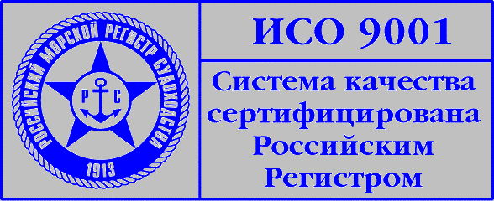

PRESS-RELEASE

Stena Bulk Becomes a New Partner of Academy

Stena Bulk (Northern Marine Management) company has signed a contract with AMSMA to train deck officers of their Baltic tankers for operating in Russian ports in winter conditions.

The training program includes theoretical training and familiarization with harsh sailing conditions on the Russian North and Western part of the Gulf of Finland. Essential feature of the course is the practical training on the specialized ship handling simulator modeling ice conditions with visualisation of areas of operation. According to the shipowner’s order the mathematical models of Aframax (Stena Arctica, dwt: 117,099) and P-max (Stena Paris, dwt: 65,125) tankers are to be designed and installed on the simulator. The STENA company has become the 12th customer of the Academy’s ice navigation training.

Stena Bulk operates 6 million DWT fleet of 69 vessels. The company is among the leaders of tanker and container shipping and has offices in Göteborg, Moscow, London, Houston, Singapore and Beijing.

